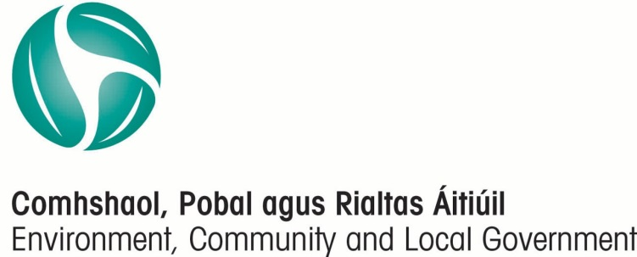

Public Participation Networks
(PPNs)

A User Guide
May 2016.

The Department wishes to acknowledge the contribution made by Social Justice Ireland in the production of this guide for the Public Participation Networks.

Table of Contents
Introduction 1
Background 1
Public Participation Networks (PPNs). 2
Principles and Values of PPN 2
Wellbeing 3
Why an organisation should join their PPN 4
Membership of PPN 4
Structures of PPNs 5
County / City Plenary 6
Secretariat 6
Municipal District PPNs 6
Linkage Groups 6
Activities of a PPN 8
Participation and Representation on Decision / Policy Making Bodies 8
Capacity Building and Training 10
Information Sharing and Communication 10
Operation of PPN 11
Budget and Workplan 11
Resource Worker 11
Relationship with Local Authority 12
Monitoring and Evaluation 12
APPENDICES 14
Appendix 1 Managing Membership 15
Appendix 2 Database Management and Data protection 16
Appendix 3 Managing a Flat Structure 18
Appendix 4 Secretariat 20
Appendix 5 Dealing with requests for PPN Representation 21
Appendix 6 Roles, Rights and Responsibilities of Linkage Group 23
Appendix 7 Role, Rights and Responsibilities of a PPN Representative 25
Appendix 8 Rights and responsibilities of a Board/Committee with PPN representation 27
Appendix 9 Glossary of terms 28

Introduction
Public Participation Networks (PPNs) were introduced following the enactment of the Local Government Act 2014. Since then they have been established in each county / city through collaboration between Local Authorities (LAs) and local volunteer-led organisations. Both LA staff and volunteers in each county / city have put huge effort into developing the new structure over the past two years. Funding for PPNs is being provided by both the Department of the Environment, Community and Local Government (DECLG) and the Local Authorities (LAs). This funding facilitates the engagement of a full time (or equivalent) resource worker and other costs. This document has been drawn up based on the experiences of PPNs around the country, and the formal guidelines drawn up by the DECLG. This guide has been designed as a live working document which may be expanded to include case studies, examples of best practice and other resources from PPNs. It is intended to support all PPN stakeholders; member organisations, Secretariats, Resource Workers and LAs in progressing a nationally consistent framework for PPNs. This will serve to ensure that PPNs are effective in supporting local volunteer-led organisations to develop their capacity and have a real voice in policy making in their County / city.

Background
Volunteer-led organisations make a significant contribution to the social, cultural, economic and environmental fabric of Ireland. Groups range from large sporting organisations and their individual clubs, to small entities like choirs or art collectives etc. Some have a national remit with a local branch network while others just operate in a specific area. Volunteer led organisations provide many essential services; economic, community, social and environmental. Some employ paid staff, while others operate totally with volunteers. Large or small, local or regional, all enhance the lives of their members and the communities which they serve. In addition, they have huge experience and expertise in the issues that directly affect people, communities and the environment in their areas of operation. According to the Central Statistics Office in 2015, over 520,000 people volunteer in organisations with an equivalent annual value of €1bn annually (based on minimum wage).
International institutions such as the EU and OECD highlight that the participation of citizens in public life and their right to influence the decisions that affect their lives and communities are at the centre of democracy. Open and inclusive policy-making increases public participation, enhances transparency and accountability, builds civic capacity and leads to increased buy-in and better decision-making. The PPN structure is designed to be a key player in delivering this vision in Ireland.
PPNs were developed on the recommendation of the Working Group on Citizen Engagement which reported in late 2013. This report contains a detailed review of literature and practice on the subject.

Public Participation Networks (PPNs).
PPNs are collectives of environmental, social inclusion, community and voluntary organisations in a County / city which
- Facilitate the participation and representation of communities in a fair, equitable and transparent manner through the environmental, social inclusion, community and voluntary sectors on decision making bodies
- Strengthen the capacity of communities and of the environmental, social inclusion, community and voluntary groups to contribute positively to the community in which they reside/participate
- Provide information relevant to the environmental, social inclusion, community and voluntary sector and acts as a hub around which information is distributed and received.

Principles and Values of PPN
The DECLG recognises that there may be some small local variations in how PPNs are implemented across the country. However, each PPN should operate according to the Guidelines and adhere to the following principles and values, being:–
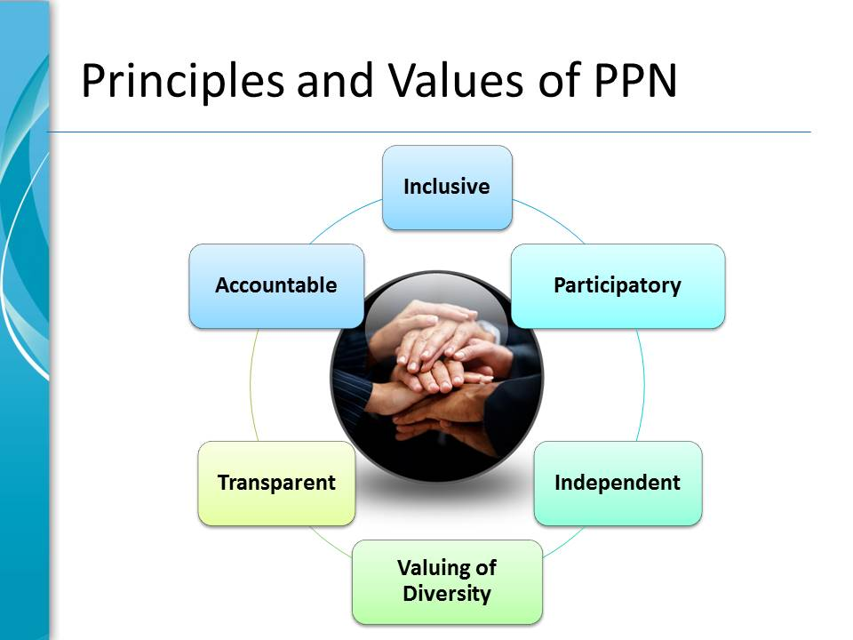
- Inclusive of all volunteer led organisations in their area, and actively seeking the inclusion of groups which may traditionally be marginalised.
- Participatory, open, welcoming, respectful, collaborative and facilitatory; the PPN will encourage participation by members in all aspects of its operation. It is a flat structure. Clear communications to and from members using a variety of traditional and new mechanisms are essential to achieve this. The PPN should support new or inexperienced members to develop their skills and capacity.
- Independent from the Local Authority and of any vested interests. Open, flat and participatory working structures support this.
- Valuing of Diversity and recognising that the sectors are broad and made up of people with many different opinions. It is not expected that the PPNs will come up with a ‘one voice response’ but that it will feedback the issues and suggestions raised by a broad range of environmental, social inclusion, community and voluntary groups.
- Transparent in its processes, procedures, dealings with its member groups, representatives, Local Authority etc. It should communicate openly, regularly and clearly with all members.
- Accountable to its member groups, via implementing and abiding by good governance structures, policies and procedures.

Wellbeing
Each PPN is charged with developing a “Wellbeing Statement” at both Municipal District and County / city level. A wellbeing statement looks at what is required for the wellbeing of individuals and communities, now and for the generations to come. Wellbeing is a multifaceted entity combining social, economic, democratic and environmental factors. It requires that basic needs are met, that people have a sense of purpose, and that they feel able to achieve important goals, to participate in society and to live the lives they value and have reason to value. This can be represented diagrammatically.
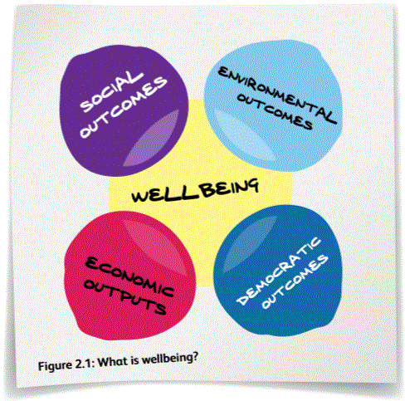

Why an organisation should join their PPN
By joining a PPN an organisation will get:
- Access to relevant information on funding and grants coming through the LA.
- The opportunity to advertise their activities via the PPN newsletter, website, emails etc.
- Access to capacity building and training events which will support them in their work.
- Access to information on decisions and proposals being made in their county / city and the ability to comment on and input to them, along with other PPN member organisations.
- An opportunity to network with and learn from other organisations in the county / city who may be involved in similar types of projects.
- The opportunity to become part of a Linkage Group for a Board or Committee of interest and be able to have their views heard and contribute to local policy.
- The opportunity to nominate members to sit on a Board or Committee on behalf of PPN.

Membership of PPN
PPN is designed to accommodate the full and diverse range of volunteer led organisations in the county / city. Membership is open to groups which
- Are active and with a postal address in the county / city
Each Secretariat is responsible for the management of the PPN database in their county / city, subject to data protection legislation.
- Operate on a not-for profit basis
- Are volunteer led (organisations may have paid staff, but must be under voluntary control)
- Are independent i.e. not a sub-committee or subgroup of another organisation
- Have at least 5 members and are open to new members
- Have an appropriate governance structure e.g. a constitution / set of rules / financial procedures
- Meet regularly
- Are in existence for at least six months
- Are non-party political.

Each organisation must then choose to be part of one “college” which represents their primary interest. These are:

- Social Inclusion: An organisation whose main activity centres on working to improve the life chances and opportunities of those who are marginalised in society, living in poverty or in unemployment using community development approaches to build sustainable communities, where the values of equality and inclusion are promoted and human rights are respected.
- Environmental: An organisation whose primary objectives and activities are Environmental (i.e. ecological) protection and / or environmental sustainability. Such activities include permanent protection of wildlife, species specific care, organic horticulture or education, environmental education or protection, environmental sustainability, resource efficiency and recycling, invasive alien species prevention/removal. All organisations wishing to join the Environmental College must be verified by the National Environmental Pillar. Further details are available at http://environmentalpillar.ie/wp/wp-content/uploads/2015/06/Criteria-for-Membership-of-Environment-Electoral-College-of-PPN.pdf
- Community and Voluntary: All other organisations including Sports, Local Development, Social, Culture, Special Interest etc.

Each PPN can devise their own annual registration process within these general guidelines and abiding by the values of PPN as detailed above.

The PPN is responsible for keeping a database of members and communicating with them regularly. Members should support the PPN by informing them of any changes in contact details or operation.
Further information for Secretariats on managing membership can be found in Appendix 1 here.
In 2016, DECLG are rolling out a Salesforce database system to all PPNs, which will facilitate PPNs to have efficient communication and comply with data protection requirements. Further details are available in Appendix 2 here.

Structures of PPNs
PPN is a FLAT structure. This means that all groups in the PPN have an equal voice and an equal input into decision making. There is no leader, no overall spokesperson or chairperson. It is truly a collective, accommodating a wide range of diverse views and perspectives. It supports each member to develop new skills and contribute in an equal way to the organisation.
PPN is a flat structure. Any PPN which does not have such a structure must immediately move to flatten it, and this process should be completed by 30 September 2016. Evidence of this will include documentation from Plenaries, Secretariat meetings etc.
The main decision making body of the PPN is the Plenary (i.e. all the independent member groups) which should meet at least twice every year to review the workings of the PPN and set the agenda for the coming period. The elected Secretariat is responsible for the administration of the PPN between Plenary meetings. Subsets of the PPN such as Municipal District PPNs and Linkage Groups also inform the process. This is a new way of working which differs from a traditional hierarchical structure and is undoubtedly challenging. However, there is much evidence around the country of it operating well. Some methodologies which support the flat structure and participation are given in Appendix 3 here.
A PPN may decide to underpin their operation with a formal legal framework such as a company or a co-operative. If they do so, they must ensure that this does not detract operationally from the flat structure.
During this developmental stage, PPN Secretariats have taken on the onerous tasks of establishing the new structure and making recommendations to the Plenary for ratification. However, as the members understanding of the Plenary evolves, the Plenary will have a more agenda setting role.

County / City Plenary
The Plenary (all the member organisations together) is the key decision maker of the PPN, meeting at least twice a year. Their role is to direct the operation of the PPN, setting overall PPN policy and processes. Decisions made between Plenary meetings, including the election of representatives, should be presented for ratification to the following meeting. Each independent member group has one vote in the Plenary. Plenary meetings are an ideal forum for member groups to meet and network and to hear about matters of interest to them. The county / city Plenary is also charged with developing a wellbeing statement for this and future generations in the area.

Secretariat
The Secretariat is elected by the PPN members, to be representative of the different geographical areas and the three colleges. It is an administrative body only, and its role is to
- Facilitate the implementation of the decisions of the Plenary.
- Ensure the proper functioning of the PPN in between Plenaries.
- Coordinate activities of PPN.
- Communicate extensively and regularly with all PPN members and in this process share information concerning all PPN activities as widely as possible.
- Maintain accurate records of PPN Business (hard and soft copies), including minuting meetings and circulating agendas.
- Act as a point of contact for the PPN in relation to the LA, DECLG, other PPNs and all third parties.
- Handle all correspondence on behalf of PPN, through distributing copies and drafting agreed responses.
- Manage the PPN resource worker.
Many Secretariats were elected early in the PPN process. As membership has expanded, it is worth considering re-electing the Secretariat, to reflect the wider membership. In any case, PPNs should separate the election cycle for the Secretariat from the local election cycle, to ensure that an experienced Secretariat is in place when there is a need to elect many new representatives to Local Authority committees. Some matters to consider with regard to the operation of the Secretariat are to be found in Appendix 4 here.

Municipal District PPNs
Each county is now organised into Municipal Districts, where the councillors and LA staff have certain powers relating to operations and maintenance works within the district. Each Municipal District should also have a PPN which can deal with locally based administrative matters. A Municipal District PPN is a meeting of all the member groups with a postal address in that Municipal District. Each Municipal District PPN should develop a wellbeing statement for their area as well as addressing locally based policy issues and engaging with local LA staff and elected members. For many groups, this level of engagement may have more immediate relevance to their needs compared to the larger county / city structure. In cities where there is no Municipal District Structure, it makes sense for sub PPNs to be established in defined geographical areas, perhaps based on electoral areas.

Linkage Groups
Linkage Groups are the way that PPN member organisations can have a real input into policy in their area of operation. Linkage Groups bring together stakeholder organisations with a common interest to discuss their diverse views and interests in a specific policy area. These groups elect PPN representatives to Boards or Committees, receive feedback from those representatives, and direct their activity. They may also set policy priorities and input into consultations etc. on behalf of PPN. This in turn, helps the member organisations to gain a deeper understanding of the local policy process. It is important to note that the role of a Linkage Group is to facilitate and enable organisations to articulate a diverse range of views and interests within the local government system, not to reduce or homogenise this diversity.
Linkage Groups should be established when representatives are being selected. In the beginning, facilitation of the Linkage Group is likely to be by the Resource Worker, but as time goes on, each Linkage Group should become self-facilitating. However, the Secretariat must oversee the correct functioning of the group, and that it remains open to new members. It is essential that all member groups be encouraged to participate in one or more Linkage Groups. In some cases, potential stakeholder groups may have to be approached directly and invited to join a Linkage Group to ensure all voices are heard. Further information about the roles and responsibilities of Linkage Groups are in Appendix 6 here
Case Study: Age Friendly County
If the PPN were asked to nominate a representative to an “Age Friendly County” task group, they would write out to all the members asking groups with a particular interest in ageing and older people to join a Linkage Group. This would bring together people from organisations such as active retired, carers, meals on wheels, voluntary day-care centres, community alert etc. This Linkage Group would then meet and discuss the most important issues for them, and what the county needs to do to become really “Age Friendly”. They would elect a representative to sit on the “Age Friendly” task group and bring their concerns. After each “Age Friendly” meeting the representative would report back to the Linkage Group on progress, and the Linkage Group would discuss the issue and direct the representative how to proceed. The Linkage Group members would also feed back to their own organisation explaining what policies were being suggested, and getting their input.
The outcomes will be
A more “Age Friendly” county because of the input from the PPN representative, which directly benefits the PPN members.
Linkage Group members will have networked together and learned useful information about how the policy process works.
Together they can monitor the new “Age Friendly” policies and feedback both successes and challenges to the Council.

1 Diagrammatic representation of PPN Structure
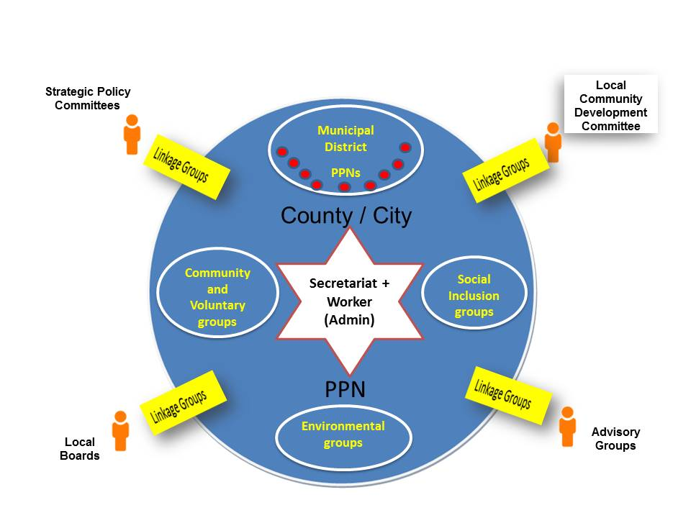

Activities of a PPN

Participation and Representation on Decision / Policy Making Bodies
LAs and other local bodies have a range of Committees and Boards to support them in their work and policy development by involving external expertise. This expertise can be drawn from sectoral interests such as employers, farmers, trades unions, and the community. The representation of environmental, social inclusion, community and voluntary voices on decision making and advisory bodies is a core function of PPNs.
The PPN should be the “go to“ organisation for all bodies in a county / city who wish to benefit from community and voluntary expertise at their table. The PPN should also be proactive in promoting the benefits of community representation on Boards and Committees. At minimum, all community representatives on LA sponsored bodies MUST come via the PPN electoral process. During the development of PPN some interim appointments may have been made, however, going forwards, all environmental, social inclusion, community and voluntary representatives must have a PPN mandate and the benefit of an active Linkage Group to support their work.
Local Authorities must ensure that ALL Environmental , Social Inclusion, Community and Voluntary representatives on their Boards and Committees come through the PPN electoral process. Where this is not the case, the situation must be regularised by 30 September 2016.
The following important principles govern PPN representation and are critical for success
- All PPN representatives on Boards or Committees should be elected by, report to and take direction from a Linkage Group of member stakeholders in the issue the Board or Committee deals with. They do not represent their own interests or those of their own organisation(s).
- The Linkage Group structure facilitates the development of a cohort of people within the community at large who have a deeper understanding of policy issues and their impact. Initiating and empowering Linkage Groups is an essential part of the work of PPN.
Any PPN which has an individual occupying multiple seats, or does not have Linkage Groups in place for all Boards and Committees upon which it has representatives must regularise this matter by 30 September 2016.
- Representation should be spread widely in terms of gender, geography and type of organisation.
- An individual should only represent PPN on ONE Board or Committee. The only exceptions to this would occur when NO other person can be found, and even in this case, the seat should only be held on a temporary or interim basis pending a recruitment campaign from within the membership. This temporary period should not exceed 6 months or 2 meetings whichever is the lesser.
- PPN representation is based in volunteer led organisations and, as such, is a separate process from Government Politics e.g. TDs, MEPs, Senators, Councillors etc. Thus
  - Elected representatives of Local Authorities, Oireachtas members or MEPs cannot be nominated through this process.
  - If anyone nominated through this process subsequently decides to enter electoral politics, they must immediately resign their PPN representative role.
  - A person who has been an elected representative of any level of Government (local or national) may not be chosen to represent PPN in any representative role for one year after completing their term of office.
Details and suggestions for managing the selection of representatives are included in Appendix 5 here.

Representation for improved decision making
Having PPN representation on a Board or Committee is a huge advantage. It enables the concerns and experiences of the community to be incorporated at an early stage of policy development, leading to more positive outcomes. It also supports the monitoring and evaluation of existing policies. However, effective representation brings challenges for both the PPN representatives and for the Board or Committee on which they sit. There needs to be mutual respect and appreciation of the contribution and role of PPN representatives as well as those of Statutory Agencies or other professional bodies. Some modifications in the operations of Boards or Committees are often required to facilitate volunteer PPN representatives. Some good practice guidelines for this are found in Appendix 8 here.
Representing the PPN on a Board or Committee is a serious task which requires knowledge and skills on the part of the representative and their role, rights and responsibilities are detailed in Appendix 7 here. Volunteers should never be out of pocket for their participation on Boards or Committees, and it is the role of the relevant Board or Committee to pay expenses. Only in very specific circumstances where the Board or Committee has absolutely no resources, should the PPN pay expenses to their representatives. If a PPN representative takes on a supplementary role within a Board or Committee which incurs extra costs, those costs are the responsibility of the Board or Committee, not of the PPN. For example, if a PPN representative attends an event on behalf of their Board or Committee, the cost of that must be borne from the Board or Committee’s own resources.

Representatives’ Charter
Each PPN should draw up a representatives’ charter to show the interlocking relationships between Linkage Groups, Representatives and the Boards/Committees they sit on. The roles, rights and responsibilities of each element as outlined in Appendix 6 to Appendix 8 here can form the basis of such a charter.

Capacity Building and Training
Volunteer led organisations face many challenges as they work to enhance their communities. One of the roles of PPN is to support them to achieve their objectives, both within their own areas and within PPN. Actions under this heading can include formal training, networking, mentoring, conferences, seminars etc. on topics of interest. Topic could include accessing and managing funding, best practice under the Charities Act and Governance Code, committee skills, strategic planning etc. Training and support is also required for Representatives and Linkage Groups on policy matters. PPNs may collaborate with other service providers e.g. Education and Training Boards, Volunteer Centres or Local Development Companies to devise and deliver this training.

Information Sharing and Communication
The vision of PPN is that it will be “the main link through which the LA connects with the community, voluntary, environmental and social inclusion sectors” and also “Provide [relevant] information ……. and act as a hub around which information is distributed and received.
This access to information is one of the greatest benefits for member organisations. LAs need to ensure that all potentially relevant information is sent to the PPN for circulation. This can include notice of new plans, formal or informal consultations on policy, information on grants, events, conferences etc. PPN member organisations can also use the facility to advertise their own activities. It is also open to statutory agencies operating in the county / city e.g. HSE, ETB etc. to use the PPN mechanism to share information with the wider community.
Of course, information sharing also involves feedback from Linkage Groups and Municipal Districts, and an opportunity for organisations to discuss important issues within PPN. To achieve this, it is important to have clear ways for member groups to feed in and communicate. Social media type sites can be very useful for this process. Many PPNs produce a regular email newsletter and also have a website and Facebook Page or Twitter Account. However, not all groups are online and poor broadband and/or IT skills may inhibit some organisations from participating. It is therefore essential to use a wide variety of communication tools including post and print.

Operation of PPN

Budget and Workplan
DECLG has allocated each PPN up to €50,000 in 2016, to be matched with at least €30,000 by the LA. If the LA contributes less than €30,000, the Department’s contribution will decrease on a pro rata basis. This funding should be used to employ a resource worker and to manage its operations. While it may be administered by another body, this budget must be under the control of the PPN. The PPN is also free to apply for further grants and funding to support additional pieces of work, which are consistent with the workplan.
Each PPN via the Secretariat must draw up an agreement with their LA on a workplan for the year to cover the areas of:
- Participation in decision making and representation i.e. managing elections, representatives and Linkage Groups, participating in consultations and other fora, developing positions on key issues etc.
- Capacity Building i.e. working with member groups to deepen their understanding of and participation in PPN, assessing training needs and offering relevant training, facilitating networking and sharing of best practice between member groups, developing networks etc.
- Information Sharing and communication i.e. working with members, developing and maintaining a website, designing and publishing a regular newsletter,
- Other activities i.e. managing an office and resource worker, holding regular meetings of the Secretariat, Municipal District PPNs, Plenary, liaising with the LA, managing the database, monitoring and evaluation, general administration etc.
A draft workplan which can be modified to suit each PPN was circulated and is available from DECLG.

Resource Worker
Each PPN has a budget for the resource of a full time equivalent skilled Development Worker, relevant office space and equipment. This person’s role is to support the Secretariat and to co-ordinate the PPN in accordance with the workplan. Resource Workers can be employed under a variety of arrangements including secondment from the LA, hosted in an external organisation, employed directly by the PPN etc. (see Circular CVSP1/2015). The PPN Secretariat should be fully involved in the recruitment process, which must be clear and transparent.
In cities / counties where the worker is not yet in place, or is not managed directly by the Secretariat, this must be prioritised, and any obstacles to the appointment of the worker removed as quickly as possible and no later than 30 September 2016.
Whatever the arrangement, it is essential that the worker is managed by the Secretariat on behalf of the Plenary, and that good HR practices are adhered to.
The workload involved in running a PPN is considerable and Secretariats may wish to consider taking on administrative support trainees via work placement schemes such as Community Employment, JobBridge, Tús, Gateway etc. In such cases, they must ensure that high quality training and work experience is available to the person.

Relationship with Local Authority
The guidelines state that “The PPN will be the main link through which the Local Authority (LA) connects with the community, voluntary, environmental and social inclusion sectors” and “PPN … will … enable the public to take an active formal role in the policy making and oversight activities of the LA’s area of responsibility.” The intention is for a collaborative partnership approach. Positive relationships between PPN and the LA are essential for success. Each PPN and LA should draw up a clear memorandum of understanding to govern their operations and funding (draft available from DECLG). Key issues to be covered are
Each PPN and Local Authority should have agreed a formal Memorandum of Understanding to govern their operations by 30 June 2016 to facilitate the drawdown of funds in July 2016.
- PPNs are independent from the LA and LAs have a responsibility to support the PPN to be independent.
- Public participation must be seen as an important and valued element of policy development, implementation, monitoring and evaluation right throughout the LA and not just the prerogative of the Community Section.
- Any reports or returns regarding the PPN must be signed by representatives of both the PPN and LA.
- Where conflict arises between a PPN and LA, which cannot be resolved locally, the Department of the Environment, Community and Local Government is the final arbiter. They can be contacted via Deirdre.kearney@environ.ie

Monitoring and Evaluation
Each PPN and LA should have a plan to monitor their own activities against the workplan and against the national Guidelines. LAs and PPNs will report twice a year on their progress to the Department of Environment, Community and Local Government. Satisfactory submission of these reports will trigger a financial drawdown, and also identify areas of best practice and/or support needs.

PPN National Advisory Group
The Working Group Report on Citizen Engagement with Local Government recommended that the work of the PPNs should be monitored and evaluated regularly in line with best practice. In order to achieve this objective, a PPN National Advisory Group has been established to aid in the further development of PPNs. This group will provide the necessary oversight, monitoring and evaluation of the PPNs and will serve as the channel through which performance indicators etc will be collated and reported to DECLG.

It is intended that the group will:
- Develop key performance indicators for PPNs and Local Authorities in conjunction with DECLG.
- Support consistency and coherent roll out of PPNs in line with national guidelines.
- Analyse and discuss local progress and liaise with DECLG on addressing priority issues identified.
- Monitor progress on the development and implementation of PPNs across the country to ensure consistency of implementation across local authority areas.
- Where inconsistencies are identified, make proposals on how these issues can be resolved.
- Review role of the PPN National Advisory Group in 2017 and agree any further requirements for the role from 2018 onwards.

The first meeting of the group will be convened in May 2016. It is envisaged that the group will meet four times in a full year, typically once a quarter. It is also envisaged that the group will facilitate national networking events for all stakeholders to network with each other in relation to the implementation of PPNs.

APPENDICES

Managing Membership
The objective of PPN is to have as diverse a membership as possible which reflects the volunteer led activity in the county / city and is socially inclusive. Many organisations may be unaware of PPN and the benefits it can bring them, so it is the role of both the Secretariat and the LA to promote membership throughout the county / city.
PPNs should be open to new members and in particular to groups who are traditionally under represented. These include ethnic minorities, Travellers, Roma, people living in disadvantaged or isolated areas, those parenting alone, - new communities (including refugees/asylum seekers), people with disabilities, people and families living in poverty, people who are unemployed etc. Many of these groups are also targeted by the Social Inclusion and Community Activation Programme (SICAP) which is run by Local Development Companies, and it may be useful to collaborate with SICAP to outreach to these groups.
The Secretariat is responsible for managing the membership database. They may delegate its operation to a third party, but it must be under their control and direction.
The Secretariat should bring to the Plenary the criteria for membership (within the guidelines). When a group seeks to register, and it is not clear if they fit the criteria, the Secretariat can request further information. In some cases, a category of Associate membership may be added for groups who do not fit all the criteria. Such groups would be able to receive information and access training etc., but would not have a vote.
Member groups should be able to self-select as Community and Voluntary or Social Inclusion organisations based on the definitions provided. In some cases, the Secretariat may offer guidance. Groups who wish to be categorised as Environmental must be approved by the Environmental Pillar. The Secretariat can send a list of such applicant groups, and a description of their environmental activity to Environment Pillar, MACRO Centre, 1 Green Street, Dublin 7, Telephone: 01 8780116 Email: office@ien.ie
Groups should re-register with PPN every year, to ensure that their information is up to date. It should be possible to do this using ICT in a way which is not time consuming or administratively burdensome. Each PPN should draw up a protocol for re-registration. The PPN contact point(s) in a member organisation are critically important for the distribution of newsletters and other information. As such they should be active users of email. An individual should not be the contact point for multiple groups. Because of the separation of the functions of Public Representatives and the PPN, Councillors, TDs Senators and MEPs should not be the PPN contact point for organisations.
To encourage active participation, members should receive regular information about the PPN, its operation and how they can get involved. While time consuming, direct outreach to groups has proved very effective in explaining the benefits of membership, and encouraging engagement.

Database Management and Data protection

Client Relationship Management (CRM) database

DECLG invited a proposal submission for the development and implementation of a database to effectively support the work of the PPNs. What was required was a robust data and information management system that all PPN’s can use. Additionally there was the important factor of commonality – all using a similar and standard package. The database chosen will, it is hoped, enable each Resource Worker to manage a variety of administrative and communications activities in relation to the work of their PPN.

Salesforce

Salesforce, the chosen product runs entirely in the cloud, meaning it’s all online – no software, no hardware. There are no expensive setup costs, no maintenance; users can work from any device with an internet connection – smartphone, tablet or laptop. It’s a complete integrated solution for managing all interactions with organisations customers/clients.
Salesforce offers a powerful web based Client Relationship Management (CRM) platform. The system provides a number of core modules which can be readily configured to meet the specific needs of users. These include;
- Contact management - this module is used to capture and manage information regarding individuals, including personal detail and related service information
- Organisation module is used to store details on organisations and community and network groups. Contacts can be linked to organisations
- Campaigns/Programme Sessions module can be used to manage events and meetings such as linkage group and plenary meetings. It will also support event and training enrolment and management.
- Reports - this module provides a flexible and powerful facility to generate a variety of custom reports to meet the needs of the organisation
- The Calendar module provides for individual calendars and allows you to see and share calendars with other staff.
- Communications – the CRM will also manage mass communications such as online Organisations registrations, Mass Email and an SMS texting system.

The database will provide a means for each PPN Resource Worker to gather and manage a database of member organisations, contacts within the PPN area. It will also provide a facility for the Resource Worker to manage a variety of communications processes and events such as email campaigns, newsletters, workshops and training events and to log and track meetings and attendances at meetings. The information gathered will provide data for reporting.

The system will initially be developed using a pilot group of PPNs with rollout and adoption by the other PPNs nationwide following the pilot phase. The pilot phase commenced in late April (2016) and will be followed by the general roll out expected to be completed by years end.

The focus of the pilot group phase is to work closely with an initial group of PPNs to:

- develop the system to meet common processes
- build the necessary security structure to restrict PPNs access to their own datasets
- develop a report suite to meet the requirements of the PPN and
- build a suite of national level reports.

It is envisaged that individual PPNs may have a need for a small number of additional record fields and/or picklist values to support their particular operations. The development team will examine these requirements with the PPNs during the initial requirements workshop of the pilot group phase.

In the matter of security, Salesforce provides various security features protecting access to the system, access to data modules and even access to individual data fields. Salesforce allows for control as to who can access the system, who can access particular modules and what can be seen when accessed. As a hosted service solution Salesforce manages systems enhancements / updates and data backup. As such organisations using the system get the benefits of updates as they become available. In the event that data records are deleted, Salesforce provides a recycle bin and a roll back and recovery mechanism for up to 15 days. Salesforce provide a facility to take a backup of the database.

Managing a Flat Structure
Having a flat structure ensures that no single voice or group of voices controls the PPN. It means that there is collective responsibility for getting things done and achieving the aims of the workplan. This develops the capacity of the whole group and means that all members understand all aspects of the process.
In the flat structure the final decisions are made by the Plenary i.e. all the member groups. So that they can make these decisions it is vital that they get as much clear and transparent information as possible. It is very important that the flat structure is promoted in all communications to members and that the language used in documents, websites and meetings is inclusive and encourages wide and open participation. Meetings of the Plenary, Secretariats, Linkage Groups, Municipal Districts etc. should all be run using methods which encourage everyone to participate equally. Ways of doing this include
- Holding meetings at different times and in rotating or central locations so that a variety of people can attend. Saturdays and evenings tend to suit volunteers. Daytime meetings often exclude working people. Be aware that a time and place that suits current members may put new members off coming.
- Circulating documents well in advance of the meeting so that people will be able to read them and prepare. This particularly important where delegates may have to discuss issues with their own organisations.
- Sitting people in a circle, or at round tables. Giving every person an opportunity to introduce themselves to the whole group or their table as appropriate.
- Having opportunities for small group discussions, or buzz sessions with 2-3 people to discuss key items.
- Record all points made during a meeting, via flipcharts etc. and include in written documentation of the meeting, which is circulated. This shows people that their points have been listened to and taken into account.
- Be open to new or innovative technologies via Skype, Social Media etc which can
- Allow time for networking before, during or after meetings, and make a point of chatting to newcomers or those who may know few others.
- Evaluate sessions afterwards with all participants.
- There are a number of methodologies which can facilitate open and intimate discussion, and link ideas within a larger group to access the collective wisdom in the room. Such tools can enable groups of all sizes to deal with hugely complex issues in a very short period of time. Examples of these tools include World Café and Open Space.
Secretariats are charged with managing the PPN between Plenaries and directing the Resource Worker. To maintain the flat structure, Secretariats have come up with practical ways of working such as
- Rotating the facilitator/ convenor of meetings regularly (every 1-2 meetings). During that period, that person can sign documents etc. on behalf of PPN PROVIDED that they are mandated to do so by the Secretariat.
- Having a facilitator / convenor group e.g. the incoming facilitator, current facilitator and outgoing facilitator working together to guide the process. Each role should also rotate every 1-2 meetings, with all Secretariat members who wish to having an opportunity to facilitate.
- Setting up short term task based subgroups which report to the Secretariat and ultimately to the Plenary e.g. Finance, Communications, Membership, Recruitment etc.
- Regularly reassessing the composition of subgroups and rotating people on and off them. PPN members who are not on the Secretariat are eligible to join such subgroups if deemed appropriate.
- Having clear processes and procedures for the PPN which are agreed by the Plenary.
The flat structure is challenging and a non-traditional way of working which people may find difficult initially. However, it is core to the mission and ethos of PPN, and every group must take steps to implement it.

Secretariat

Secretariat membership
The membership of the Secretariat is designed to be as broad as possible, and reflective of the diversity of the membership. It must include at least one representative from each of the Municipal Districts in a county (or set geographical areas within the cities), and equal numbers (but at least two people) from each of the three electoral colleges (Environmental, Social Inclusion, Community and Voluntary). Where vacancies occur, they should be filled as soon as possible.
People elected to the Secretariat must be nominated by a member organisation in their geographical community or college. The electorate for that position is comprised of the members of that geographical community or college. For example, candidates for a Social Inclusion vacancy must be nominated by a Social Inclusion organisation, and it is only the Social Inclusion organisations which have a vote for this position. The college system ensures that all three distinct voices (Environment, Social Inclusion, Community and Voluntary) within PPN can be equally represented and clearly articulated.
No volunteer or group of volunteers should be able to / left to administer the PPN on a long term basis. A truly participative PPN requires a regular refreshing of different roles. As the organisation evolves, it may be appropriate to have rotating retirements from the Secretariat to ensure continuity.
Possible questions to be considered include-
- What is the process for electing people to the Secretariat?
- How long should the term of office for a person on the Secretariat be?
- How many terms can a person serve on the Secretariat?
- If a person resigns from the Secretariat, can they be replaced by the next person on the panel from the relevant election?
- How long does a panel last for?
- If a Secretariat member does not attend meetings or participate in the work without apologies or reasonable excuse, how can they be removed?
- What expenses are payable to Secretariat members?
Policies and procedures which are developed for the Secretariat should be ratified by the Plenary.

Dealing with requests for PPN Representation
When a Board or Committee seeks a representative, they should contact the PPN Secretariat with details such as those shown below. If these details are not forthcoming, the Secretariat should request them. The more information that is available, the easier it will be to select the most appropriate representative for the role.
- Title of Board or Committee
- Function and scope of the Board or Committee
- Who are the other members
- What commitment would be expected from a PPN representative e.g. time and location of meetings, participation in subgroups, becoming a company director etc.
- What skill set(s) they would like the representative to have. (Note these cannot be overly restrictive e.g. “an interest in and knowledge of issues impacting on people in poverty” would be acceptable, whereas “be a qualified social care professional” may not.
- What expenses are payable?
- Any restrictions on membership of the Board or Committee e.g. not being an employee or member of an organisation funded directly by the Board or Committee, or not being a member of another pillar e.g. Farming, which already has representation on the Board or Committee, or coming from a particular geographical area or type of organisation. For example, a Transport Co-Ordination Unit could seek a representative from each Municipal District in a county; a Sports partnership could seek representatives from different target groups e.g. older people, people with a disability etc.
- Any potential conflict of interest which could impact on a representative’s full participation on the Board or Committee.
- Any other relevant matters.

Election Format
Each PPN should have general guidelines for the election of representatives which have been ratified by the Plenary. Within those guidelines the Secretariat must then decide –
- If they wish to accept this invitation to have representation on this Board or Committee
- How long a term of office the representatives should have
- The details of the nomination/ election process including timelines
- The documentation to be circulated to members.

Call for nominations
The Secretariat should then inform all member groups of this vacancy and invite those who are stakeholders in the issue to join a Linkage Group for that Board or Committee. This must happen in all cases. It is NOT acceptable to use an already existing Linkage Group for elections.
A possible pathway is
- Call for nominations from members of the Linkage Group. This may involve an application form where the nominee outlines their suitability for the seat, and their agreement to report back to and take direction from the Linkage Group and PPN.
- Verification of the nominees by the Secretariat to ensure they meet the criteria.
- Circulation of details of the nominees to the Linkage Group to enable them to consider them prior to the election.
- The election should generally be held at a meeting of the Linkage Group, where the stakeholders can gather to discuss the topic of the Board or Committee as well as the actual election. In some cases, a postal or electronic vote may be appropriate. In any case, the process for eligibility to vote and voting should be clear and transparent.

Electoral processes
All elections should be by secret ballot, and each PPN should establish a clear set of electoral rules which are agreed by the Plenary. It is important that these rules are robust, as they may be open to challenge. Each independent group is entitled to only one vote, and an individual can only vote on behalf on one group.
The actual election can be carried out in a number of ways. The simplest is “first past the post”, but the most representative is Proportional Representation by single transferrable vote as with a General Election. However, it can be difficult to manage the count when the electorate is small. Another variation “Eurovision” involves assigning 12 votes to the top candidate on each ballot paper, 10 to the next, 7 to the next and 6,5, 4 etc. The candidates with the highest number of votes are elected. Using these processes should reduce the likelihood of a tie. However, if a tie does occur, and neither candidate is willing to yield, then drawing lots may be used to decide who gets the seat.
In some cases, a Board or Committee will allow an alternate representative to be appointed, to attend when the elected person cannot. This should generally be the person with the next highest votes. Both the representative and the alternate should be involved in the Linkage Group. In any case the records of the ballot should be kept in case the representative can no longer attend meetings etc.
All representatives should be ratified by the Plenary at their next available meeting.

Roles, Rights and Responsibilities of Linkage Group
A Linkage Group for a Board or Committee is a collection of PPN member organisations who are stakeholders or have a particular interest or expertise in the issues being discussed at that Board or Committee. The PPN will invite all member groups to join a Linkage Group, and all who wish to join can do so, nominating individuals to attend on their behalf.

Role of the Linkage Group is to
- Elect representative(s) to the Board or Committee
- Discuss and debate the matters being discussed by the Board or Committee, to inform the representative(s), and where relevant to prioritise and develop policy positions.
- To mandate the representative to bring forward the diversity of views within the Linkage Group to the Board or Committee.
- Agree and implement a way of communicating with the representative(s) and with each other, which is effective and realistic.
- With the Secretariat to censure / remove the representative(s) if they are not fulfilling the terms of their appointment.
- To work with the PPN Secretariat and report to the Plenary as relevant.
- To work collaboratively with other Linkage Groups and representatives in furtherance of the aims of PPN.

Responsibilities of Linkage Group members are to
- To operate in accordance with the principles and values of PPN.
- Make themselves aware of what the Board or Committee they are linked to can and cannot do, having realistic expectations of what a representative can achieve, and understanding confidentiality issues which may arise.
- Be open to new organisations joining the Linkage Group, and to actively seek the input of all groups who have an interest in the area, particularly those who are traditionally excluded.
- Communicate and engage clearly and openly with the representative and other Linkage Group members, recognising that there may be differing views expressed on issues, and that the representative must bring the diversity of views to the Board or Committee.
- Take the time to read / absorb / understand communications that are received.
- Seek to develop realistic policy proposals to address issues raised and support the representative to bring views forward, by providing relevant facts and research where possible.
- Feed back to their own member groups on the work of the Linkage Group and Board or Committee.
- Inform the wider PPN of key issues and policy positions.
- Keep records of dates, attendance, outputs etc. for meetings (virtual or face to face)

Rights of the Linkage Group members are to
- Receive relevant information about the work of the Board or Committee to help them to participate fully.
- Receive regular communications (at least as frequently as Board or Committee meetings are held) from the representative on matters such as
  - Dates of Board or Committee meetings
  - Agendas for Board or Committee meetings
  - Reports from Board or Committee meetings
  - Items which require their input
- Have regular discussions by an agreed mechanism (face to face / Skype conference calls / email / social media groups etc.).
- Have their issues brought forward by the rep.
- Have Linkage Group discussions facilitated in an open inclusive way, and the views of all members accommodated.

Role, Rights and Responsibilities of a PPN Representative
A representative is elected for a fixed term to represent the issues of PPN members on a particular Board or Committee. Their election takes place according to procedures established by the Secretariat and approved by the Plenary.

Role of the Representative is to
- Attend and participate fully in meetings of the Linkage Group and Board or Committee, including any subgroups to which they may be appointed
- Bring forward the issues of the Linkage Group to the Board or Committee for their consideration, including putting items on the agenda. They are not there just to represent their own group or agenda.
- Work collaboratively with the Linkage Group to identify issues, research, policy proposals etc.
- Communicate regularly (at least as frequently as meetings are held) with the Linkage Group on matters such as
  - Dates of Board or Committee meetings
  - Agendas for Board or Committee meetings
  - Reports and Feedback from Board or Committee meetings
  - Items which require their input or are of interest
- Network and work strategically with other Board or Committee members for the benefit of the Linkage Group and of PPN, including being able to compromise while retaining the core objective.

Responsibilities of the Representative are to
- Organise Linkage Group Meetings and effective two way communications with Linkage Group members [with the support of the resource worker]
- Be able to use basic electronic communications effectively (i.e. email and internet browsing)
- Prepare thoroughly for, attend and participate actively in Linkage Group and Board or Committee meetings solely on behalf of PPN, leaving any personal, business or political interests outside
- Work openly and collaboratively with all Linkage Group members to identify issues, research, policy proposals etc., respecting the diversity of views expressed.
- Put forward opinions / views of Linkage Group to The Board or Committee and feedback clearly (non-jargon) to the Linkage Group
- Attend relevant training or networking events organised by PPN or the Committee.
- Be open and honest in dealings with all stakeholders
- Build positive relationships with other committee members for the benefit of the PPN.
- Portray the PPN and the Linkage Group in a positive and constructive way.

Rights of the representative are to
- Have active engagement from the Linkage Group, including timely responses to issues.
- Be heard and respected at both the Linkage Group and Board or Committee, with an appreciation that they are a volunteer.
- Be supported by both Linkage Group and Board or Committee members, understanding that PPN is a new and evolving process.
- Have access to an agreed outcome statement from meetings which can be circulated immediately afterwards.
- Receive relevant training to enable them to participate effectively on the Board or Committee
- Receive expenses for attending Board or Committee meetings including any subgroups and relevant training.
- Have at least some meetings held at a time and location which facilitates them.
- Receive an induction pack for the Board or Committee on taking up appointment to include
  - Terms of reference
  - Standing orders /procedures
  - Meeting schedules, locations and times
  - Contact details for all Board or Committee members
  - Access to technical support where required
- Receive timely notice of meetings (at least two weeks in advance, and more if possible) including
  - Dates and venues
  - Agenda
  - Documents to be read
- Have meetings conducted in a way that facilitates participation, open discussion and transparent decision making.

Rights and responsibilities of a Board/Committee with PPN representation
The way in which the Committee conducts its business has a huge impact on the effectiveness of PPN representation. An overformal and rigid process can make participation difficult. An open facilitative style can make it easy for all members to participate and contribute. The following rights and responsibilities are generally within the remit of the Chair or Chief Officer (or equivalent). The majority are likely to be already in place.

Responsibilities of the Board or Committee are
- To have and communicate clear terms of reference and procedures / standing orders and a vision for the Board or Committee.
- To hold regular meetings at times, dates and locations that facilitates the participation of volunteers. Ideally these dates should be set annually.
- To hold an induction meeting and have an induction pack for new members to explain the processes and procedures of the Board or Committee.
- To set the agenda in consultation with members and to enable members to put items on the agenda.
- To give one month’s notice of meetings and to circulate the agenda and any documentation for reading at absolute minimum two weeks in advance. This is to facilitate PPN members to consult with their linkage group before the meeting and to ensure that members have adequate information with which to make comments and decisions.
- To chair the meeting in an open and transparent way as to enable and value the contribution of all members and fosters a culture of active listening. This should include giving enough time for discussion and deliberation of items, and if required setting up subgroups to bring recommendations to the main Board or Committee. Decisions should be made in an open and transparent way.
- To ensure that any conflicts of interest are clearly stated and dealt with appropriately.
- To include all points of discussion within the minutes, and not to dismiss those which may be considered “only relevant to a few”. To produce an agreed “meeting outcome” document at the end of each meeting which can be shared with the Linkage Group.
- To pay travel and other expenses to members
- To offer relevant training to all members and to provide support to members in interpreting technical documents.
- To review the workings of the Board or Committee on a regular basis and to take on board any recommendations.

Rights of the Board or Committee
- Members will attend meetings, or send their alternate (where possible)
- Members will prepare thoroughly for meetings, and be able to contribute fully
- Members will feed back to their PPN Linkage Groups and take direction from them
- Members will take a full part in the workings of the Board or Committee including participation in subgroups, consultations etc.
- Members will be open and honest in their dealings with the Board or Committee, declaring any conflicts of interest.

Glossary of terms
There are a broad range of definitions covering the nature and scope of public participation and local government. Some of these are explained below:
Active citizenship means being aware of, and caring about, the welfare of fellow citizens, recognising that we live as members of communities and therefore depend on others in our daily lives.
Community Development refers to both a sector within the overall voluntary and community sector and a distinctive approach to working for social and economic development and change. This approach involves individual and collective empowerment, enabling and supporting members of a community (of place, identity or interest) to work collectively, to improve the quality of their lives, their community and their society. This “community-led” approach is often but not exclusively based on an understanding that those affected by poverty and/or disadvantage are often excluded from society due to discrimination, prejudice, lack of resources, skills, confidence and/or education.
Community refers to a place (such as a neighbourhood or wider area), identity (such as belonging to an ethnic group), or interest (such as a commitment in common with others, for example, disability rights).
LCDC: Local Community Development Committee – a Local Authority Committee with public and private members which oversees community development programmes in an area. PPNs typically have 5 members on that committee.
Linkage Group: A group of stakeholders on a particular issue who meet to make policy recommendations and work closely with a representative.
Local Authority (LA): The Department of the Environment, Community and Local Government oversees the operation and development of the local government system and provides the policy framework within which local authorities work and deliver services to the communities that they represent and serve. Article 28A of the Irish Constitution recognises the role of local government in providing a forum for the democratic representation of communities and in exercising and performing powers conferred by law.
Members are elected to a local electoral area in respect of a local authority and where that local electoral area is situated in a municipal district, those members comprise the council membership for that municipal district in addition to forming part of the plenary council for the entire local authority.
Local authorities are multi-purpose bodies responsible for delivering a broad range of services in relation to roads; traffic; planning; housing; economic and community development; environment, recreation and amenity services; fire services and maintaining the register of electors.
The elected council is the policy making forum of the local authority; the municipal district members act as a decision-making sub-formation of the overall council in respect of their municipal district area. Elected councils (operating at local authority or municipal district level) exercise ‘reserved functions’ defined in law across a range of legislation. The day-to-day management of a local authority is carried out by the executive, i.e. the full-time officials led by the chief executive. The chief executive has a duty to advise and assist the elected council in the exercise of their functions.

Local Authorities play a key role in supporting economic development and enterprise at a local level. Local Government support on the ground is critical to the success of many initiatives which drive local communities. These range from local festivals and events; design of streetscapes and village renewal schemes; support for micro-enterprises, business parks and incubation units; involvement in energy efficiency projects; promotion of rural broadband; planning for major investments in the green economy.
Local Development involves empowering local communities to sponsor innovative strategies and projects for enterprise, improving employment opportunities, education, training and community development as well as enabling them to focus mainstream programmes in a better way in their local areas (Crickley, 2000: 17).
Not for profit organisations are those whose objective is to plough any surplus income generated back into the organisation and not pay a dividend to shareholders. It includes a huge range of organisations from very small groups with no income to large charities.
Participation means combining elements of the top-down and the community-led where representatives of both can come together to promote agreed strategies. It necessitates building social capital so that members of communities can move up from the basic ‘information’ level, which means merely commenting on an agency’s intentions, through consultative and representative stages, to the ‘participation’ level involving continuous engagement in decision-making (O’Keefe; 2008: 28).
Participative (or participatory) democracy relates to ways in which individuals and communities have ways of influencing the determination of specific issues, including through referenda, discussion fora, committees, consultative procedures, opinion polls and other means of establishing the views of individuals and groups. (Putting People First – Action Programme for Effective Local Government)
Participative community based planning is a structured process through which members of a community are actively involved in identifying issues and setting priorities for action for their area.
Plenary: All groups in a PPN
Social Economy consists of enterprises that trade for a social or societal purpose, where at least part of their income is earned from trading activity, they are separate from government, and where their surplus is primarily reinvested in the social objective.
Social Inclusion: activity centred on working to improve the life chances and opportunities of those who are marginalised in society, living in poverty or in unemployment using community development approaches to build sustainable communities, where the values of equality and inclusion are promoted and human rights are respected.
Social innovations are new ideas (products, services and models) that simultaneously meet social needs (more effectively than alternatives) and create new social relationships or collaborations and provide innovative solutions to social or environmental problems.
SPC: Strategic Policy Committee – a Local Authority Committee comprised of councillors and external stakeholders which makes policy proposals on issues such as Housing, Environment, Community etc. Typically, LAs have 4-5 SPCs and each has some PPN representation.
Sustainable Development is development that meets the needs of the present without compromising the ability of future generations to meet their own needs.
Volunteering is the commitment of time and energy for the benefit of society and the community, the environment or individuals. It is undertaken freely and by choice, without concern for financial gain. Volunteering helps create a vibrant civil and active society in which individuals are encouraged and enabled to participate fully. This is an essential component of a mature democracy.
Volunteer-led organisations are those which are governed by a group of volunteers acting as a committee, board or other structure.
Well-being refers to a person’s physical, social and mental state. It requires that basic needs are met, that people have a sense of purpose, and that they feel able to achieve important goals, to participate in society and to live the lives they value and have reason to value.

http://www.cso.ie/en/releasesandpublications/er/q-vwb/qnhsvolunteeringandwellbeingq32013/
http://www.environ.ie/en/Community/CommunityVoluntarySupports/News/MainBody,36780,en.htm
http://www.nesc.ie/en/publications/publications/nesc-reports/well-being-matters-a-social-report-for-ireland/
http://www.carnegieuktrust.org.uk/publications/2015/towards-a-wellbeing-framework--short-report

